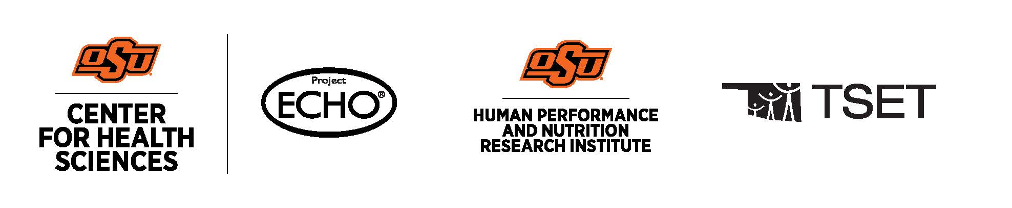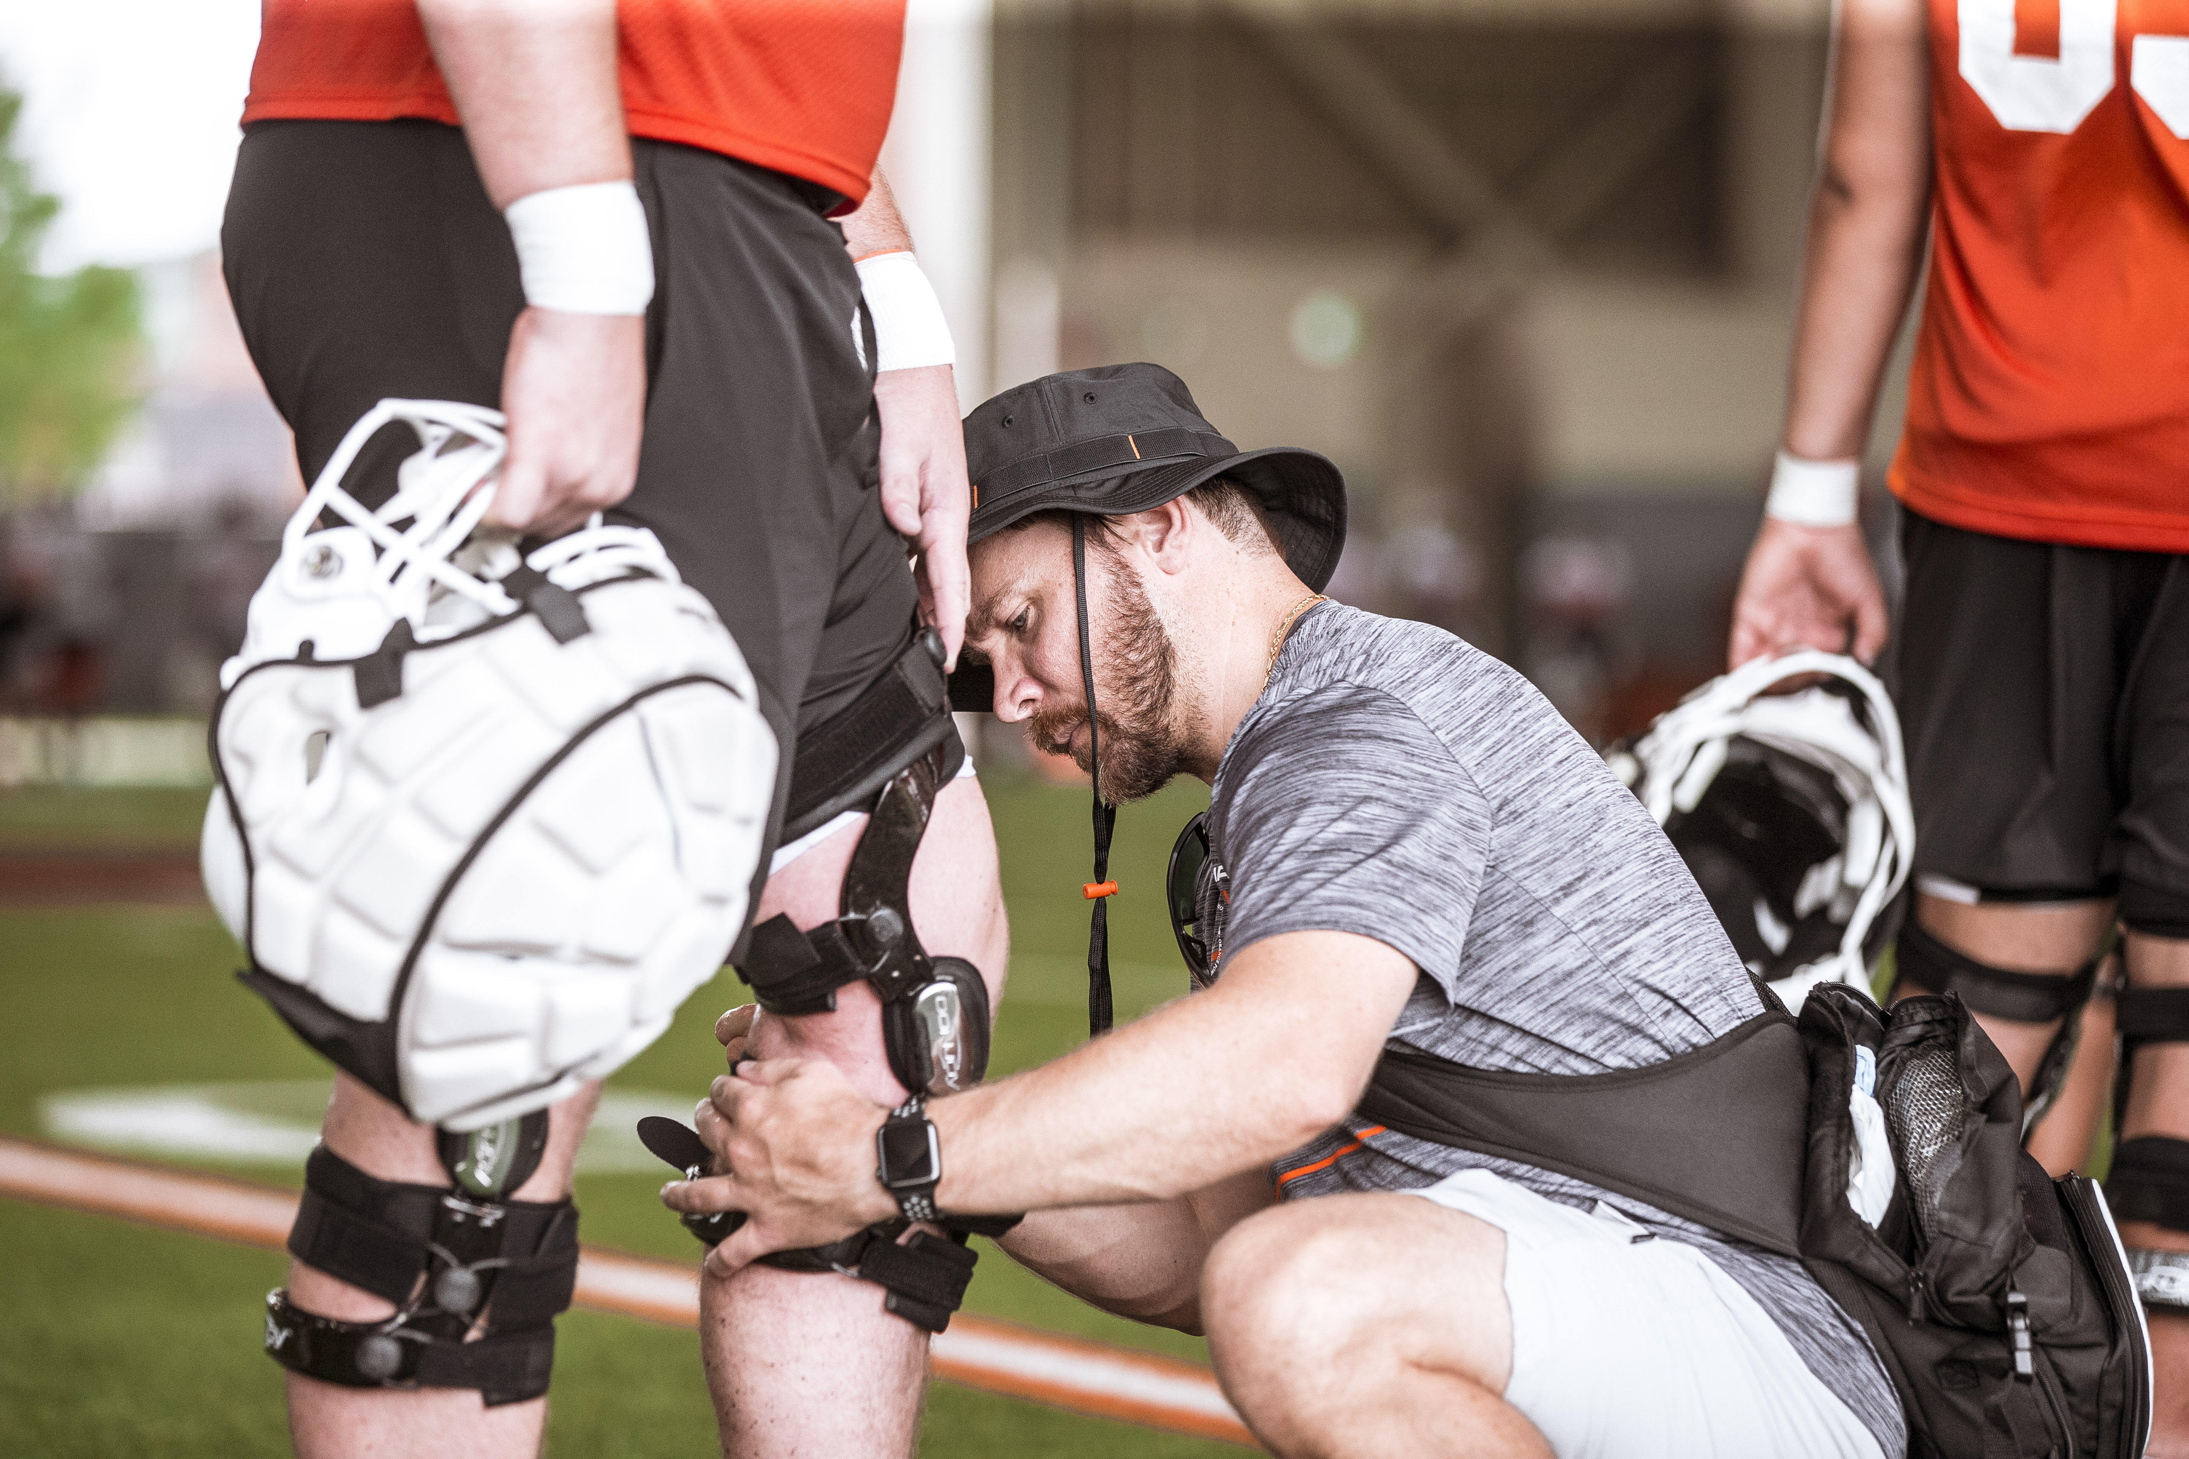  Performance Supplements  Learning Objectives  1. Defining Supplement Effectiveness and Efficacy  2. Grasping the Regulatory Landscape  3. Evaluating Supplement Safety  Schedule and Format  - Wednesday, October 25, 2023; 12-1pm  Cancellation/Refund Policy  - None. No payments necessary.  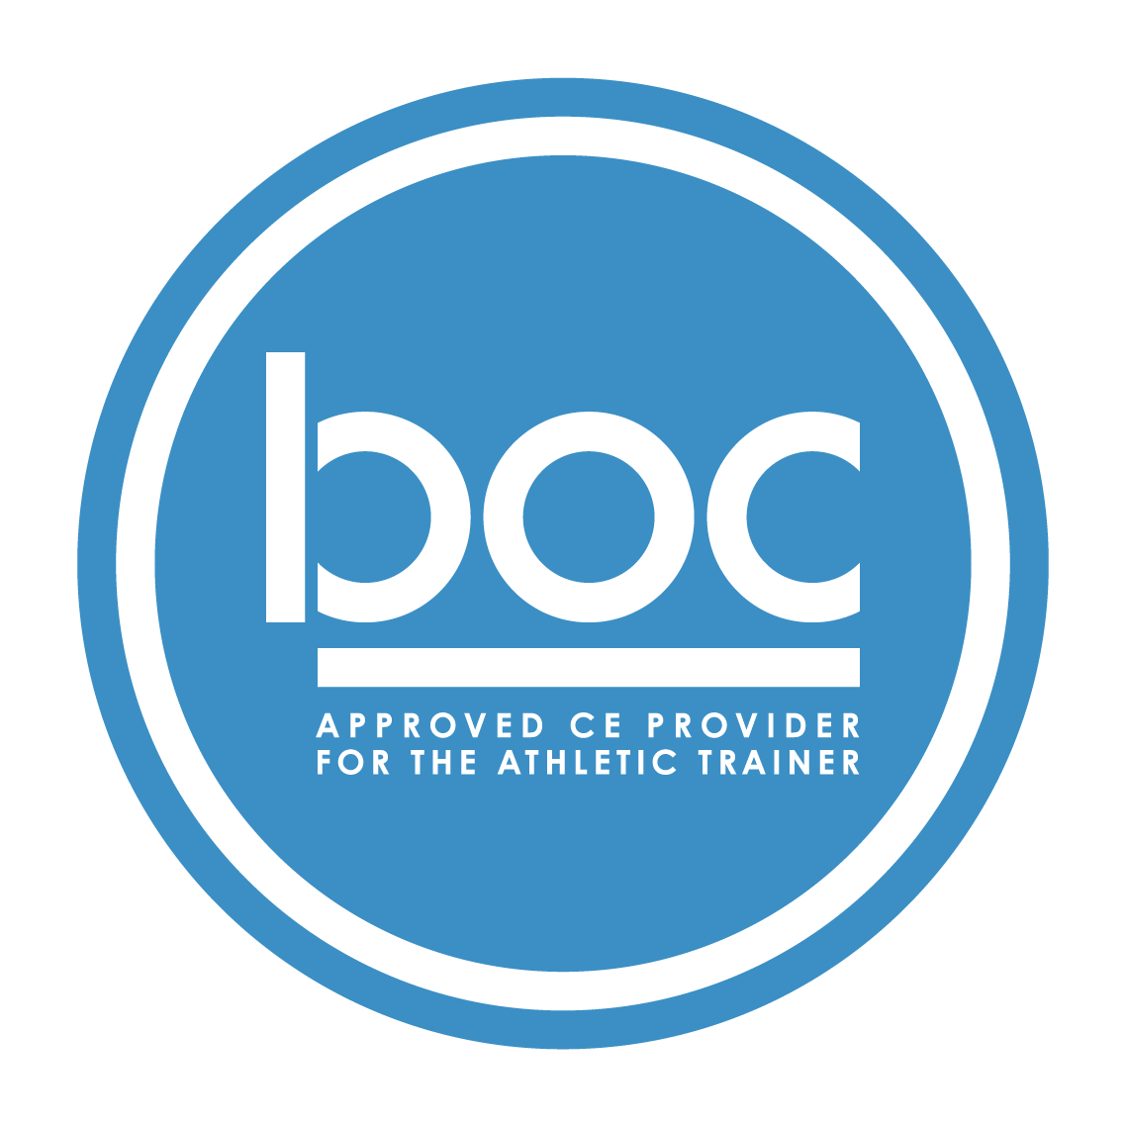  Oklahoma State University Center for Health Sciences (BOC AP#: P12117) is approved by the Board of Certification, Inc. to  provide continuing education to Athletic Trainers (ATs). This program is eligible for a maximum of (1.00) Category A  hours/CEUs. ATs should claim only those hours actually spent in the educational program. | Gena Wollenberg, PhD, RD/LD, CSSD  ____  NO REQUIRED MATERIALS OR EQUIPMENT  ____  1-HOUR CATEGORY A CEU AVAILABLE  ____  TSET Grant  NO FEES  ____  SESSIONS ARE VIRTUAL VIA ZOOM  OSU CENTER FOR HEALTH SCIENCES  1111 W 17th St  Tulsa, OK 74107  918-561-8255  Register:  https://redcap.okstate.edu/surveys/?s=3KY39MLMMHKCCHMY  Website  https://medicine.okstate.edu/echo/atsm-echo.html

